Radical anion—radical coupling proposed mechanism
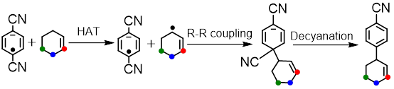
hex_dcbrad
dcbrad_cyclohexenyl
coupled
allylarene

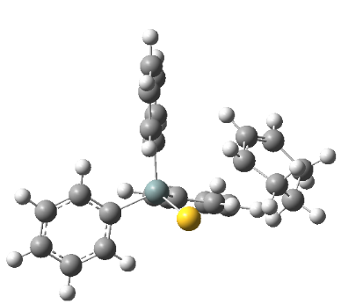
- HAT_TS

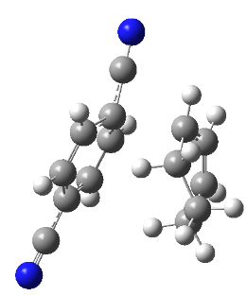

- coupling_TS

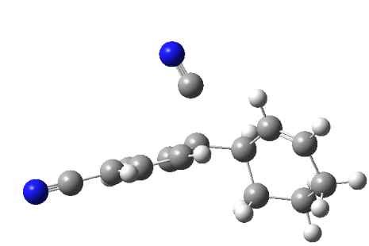

- decyano_TS

Radical anion—radical coupling proposed mechanism/deuterated
hex_dcbrad
dcbrad_cyclohexenyl
coupled
allylarene
HAT_TS
coupling_TS
decyano_TS
Radical adjacent
Radical 1 C away

Radical anion addition proposed mechanism
coupled
cyclohexyl_benzonitrile
allylarene

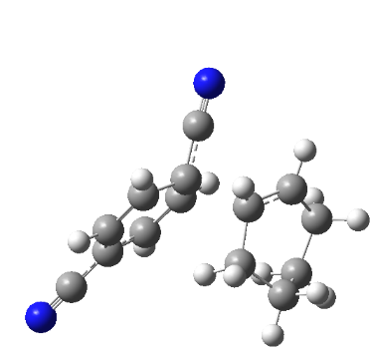

- radicaladdition_TS

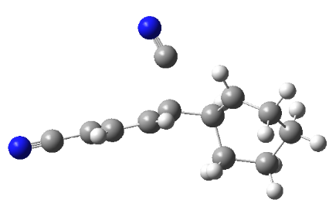
- decyano_TS

Radical anion addition proposed mechanism/deuterated (radical 1 C away)
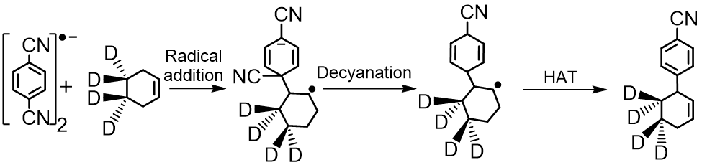
hex_dcbrad
coupled
cyclohexyl_benzonitrile
allylarene
radicaladdition_TS
decyano_TS

Radical—radical coupling proposed mechanism
dcbradfrag_hex

dcbradfrag_cyclohexenyl

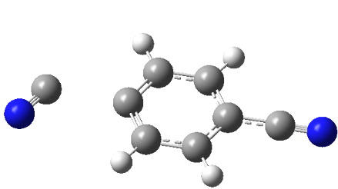
- decyano_TS

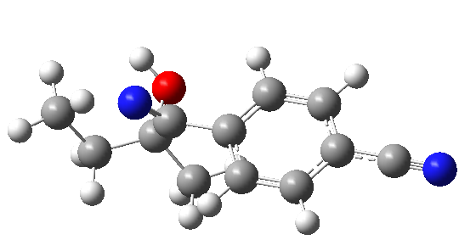
- decyano_withMEK_TS

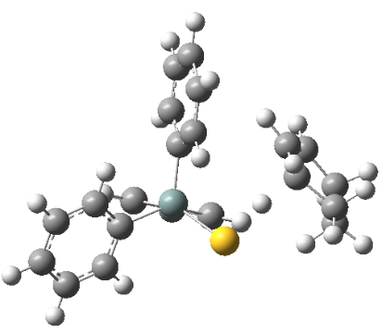

- HAT_TS

